**A MINI PROJECT ON**

## YOUTUBE TRANSCRIPT SUMMARIZER

SUBMITTED IN PARTIAL FULFILLMENT FOR THE DEGREE OF

BACHELOR OF TECHNOLOGY

IN

### COMPUTER SCIENCE AND TECHNOLOGY

BY

### 21 - Asmita Jadhav 49 - Shruti Rathod 51 - Zarna Raval

Guided By

### ”Prof. Poonam Vengurlekar”

**DEPARTMENT OF COMPUTER SCIENCE AND TECHNOLOGY**



### USHA MITTAL INSTITUTE OF TECHNOLOGY

**S.N.D.T Women’s University, Mumbai 2023-24**

**CERTIFICATE**

This is to certify that Asmita Jadhav, Shruti Rathod,and Zarna Raval have completed Mini Project report on the topic ”YOUTUBE TRANSCRIPT SUMMARIZER” satisfactorily for the Bachelor’s Degree in COMPUTER SCIENCE AND TECHNOLOGY under the guidance of Pro. Poonam Vengurlekar during the year 2023-24 as prescribed by S.N.D.T Women’s

University,Mumbai.

Guide Head Of Department

Prof. Poonam Vengurlekar Prof.Kumud Wasnik

Principal

Dr. Yogesh Nerkar

Examiner 1 Examiner 2

## DECLARATION

We declare that this written submission represents our ideas in our own words and where others’ ideas or words have been included, we have adequately cited and referenced the original sources. We also declare that we have adhered to all principles of academic honesty and integrity and have not misrepresented or fabricated or falsified any idea/data/fact/source in our submission. We understand that any violation of the above will be cause for disciplinary action by the Institute and can also evoke penal action from the sources which have thus not been properly cited or from whom proper permission has not been taken when needed.

ASMITA JADHAV(21) SHRUTI RATHOD(49) ZARNA RAVAL(51)

Date: 19/03/2024

## ACKNOLEDGEMENT

We have a great pleasure to express our gratitude to all those who have contributed and motivated during our project work. We thank our principal, Dr. Yogesh Nerkar, our HoD, Pro. Kumud Wasnik and our guide, Prof. Poonam Vengurlekar for mentoring us.

Date: 19/03/24

ASMITA JADHAV(21) SHRUTI RATHOD(49) ZARNA RAVAL(51)

## ABSTRACT

This project aims to develop an efficient YouTube video summarization system leveraging ad- vanced machine learning techniques. With the ever-growing volume of content on YouTube, users face challenges in finding relevant and concise information. The proposed system utilizes state-of-the-art natural language processing and computer vision algorithms to analyze and sum- marize video content.

The summarization process involves creating an abridged textual representation accompanied by

key visual frames, providing users with a quick overview of the video’s content. The system’s effectiveness will be evaluated through comprehensive testing and comparison with existing sum- marization methods. The ultimate goal is to enhance user experience on YouTube by offering time-efficient access to relevant information within videos.

**TABLE OF CONTENTS**

|  |  |  |
| --- | --- | --- |
| SR NO. | TOPIC | PAGE NO. |
| 1 | INTRODUCTION | 7 |
| 2 | PROBLEM STATEMENT | 8 |
| 3 | LITERATURE SURVEY | 9 |
| 4 | EXISTING SYSTEM | 10 |
| 5 | PROPOSED SYSTEM | 12 |
| 6 | HARDWARE AND SOFTWARE REQUIREMENTS | 13 |
| 7 | APPLICATIONS | 14 |
| 8 | IMPLEMENTATION | 15 |
| 9 | FUTURE SCOPE | 20 |
| 10 | CONCLUSION | 21 |
| 11 | REFERENCES | 22 |

# CHAPTER 1: INTRODUCTION

This project aims to develop an efficient YouTube video summarization system leveraging ad- vanced machine learning techniques. With the ever-growing volume of content on YouTube, users face challenges in finding relevant and concise information. The proposed system utilizes state- of-the-art natural language processing and computer vision algorithms to analyze and summarize video content. The summarization process involves creating an abridged textual representation accompanied by key visual frames, providing users with a quick overview of the video’s content. The system’s effectiveness will be evaluated through comprehensive testing and comparison with existing summarization methods. The ultimate goal is to enhance user experience on YouTube by offering time-efficient access to relevant information within videos.

Recognizing this challenge, the proposed project aims to address the need for a more time- efficient and effective way of consuming video content by implementing an automatic transcript summarization system. This system leverages cutting-edge Natural Language Processing (NLP) techniques, specifically focusing on abstractive text summarization. The goal is to create concise and meaningful summaries of video transcripts, allowing users to quickly identify important pat- terns, key concepts, and crucial information without the need to watch the entire video.

For both intermediate enthusiasts and seasoned professionals, this project offers a valuable op- portunity to gain hands-on experience with state-of-the-art NLP techniques. Implementing an automatic video transcript summarizer not only aligns with the current advancements in the field but also provides a refreshing and intellectually stimulating hobby project for professionals seek- ing to explore new applications of NLP. By engaging in this project, individuals can contribute to the development of a tool that not only saves time and effort for users but also showcases the practical and impactful applications of abstractive text summarization in the context of the rapidly evolving digital landscape

# CHAPTER 2: PROBLEM STATEMENT

The rapid growth of content on YouTube has led to an overwhelming volume of videos, making it challenging for users to efficiently consume and extract relevant information. Currently, there is a lack of effective tools to summarize YouTube videos, leaving users with the time-consuming task of manually sifting through lengthy content to find specific details.This presents a need for an intelligent video summarization system that can automatically distill the key information from YouTube videos. Existing summarization methods often fall short in handling the diverse and dynamic nature of video content, especially when combining both spoken and visual elements. Addressing this issue requires the development of an advanced solution that leverages cutting- edge technologies in natural language processing and computer vision.Therefore, the problem at hand is to design and implement a YouTube video summarization system that efficiently processes diverse video content, extracts essential information from both audio and visual components, and presents users with concise and informative summaries. This system aims to alleviate the infor- mation overload on YouTube and enhance user accessibility to relevant content within videos.

# CHAPTER 3: LITERATURE SURVEY

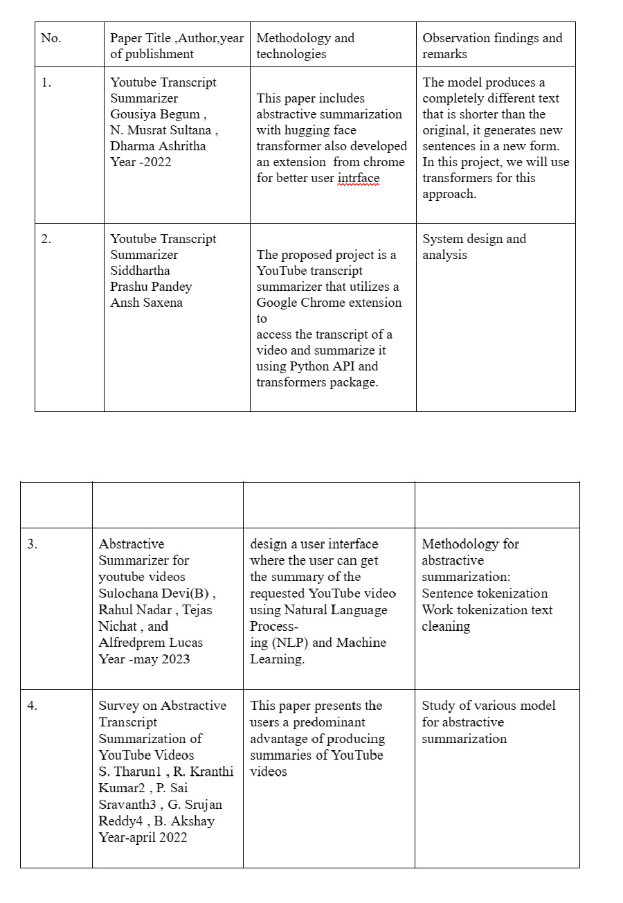

**CHAPTER 4: EXISTING SYSTEM**

Chrome Extension Integration: Users open a YouTube video and click on the summarization feature within a Chrome Extension.

HTTP Request: The Extension sends a HTTP request to the backend system.

* Transcript Retrieval: The backend system retrieves the transcript for the specified YouTube video ID.
* Summarization Process: The retrieved transcript undergoes a summarization process.
* HTTP Response: The summarized transcript is returned as a HTTP response.
* Display in Extension: The summarized transcript is displayed within the Chrome Extension interface for the user to view.
* These steps outline the workflow of the YouTube Transcript Summarizer, from requesting the transcript to displaying the summarized content in the Chrome Extension..

Disadvantages:

1. HTTP Request:

Network Dependency: The system relies on network connectivity for sending requests, mak- ing it susceptible to issues such as network latency, downtime, or connectivity issues. Se- curity Risks: Sending HTTP requests may expose sensitive information if proper encryption and security measures are not implemented.

1. HTTP Response:

Network Dependency: Similar to the HTTP request step, the system’s ability to return sum- marized transcripts relies on network connectivity, making it susceptible to issues such as latency or downtime.

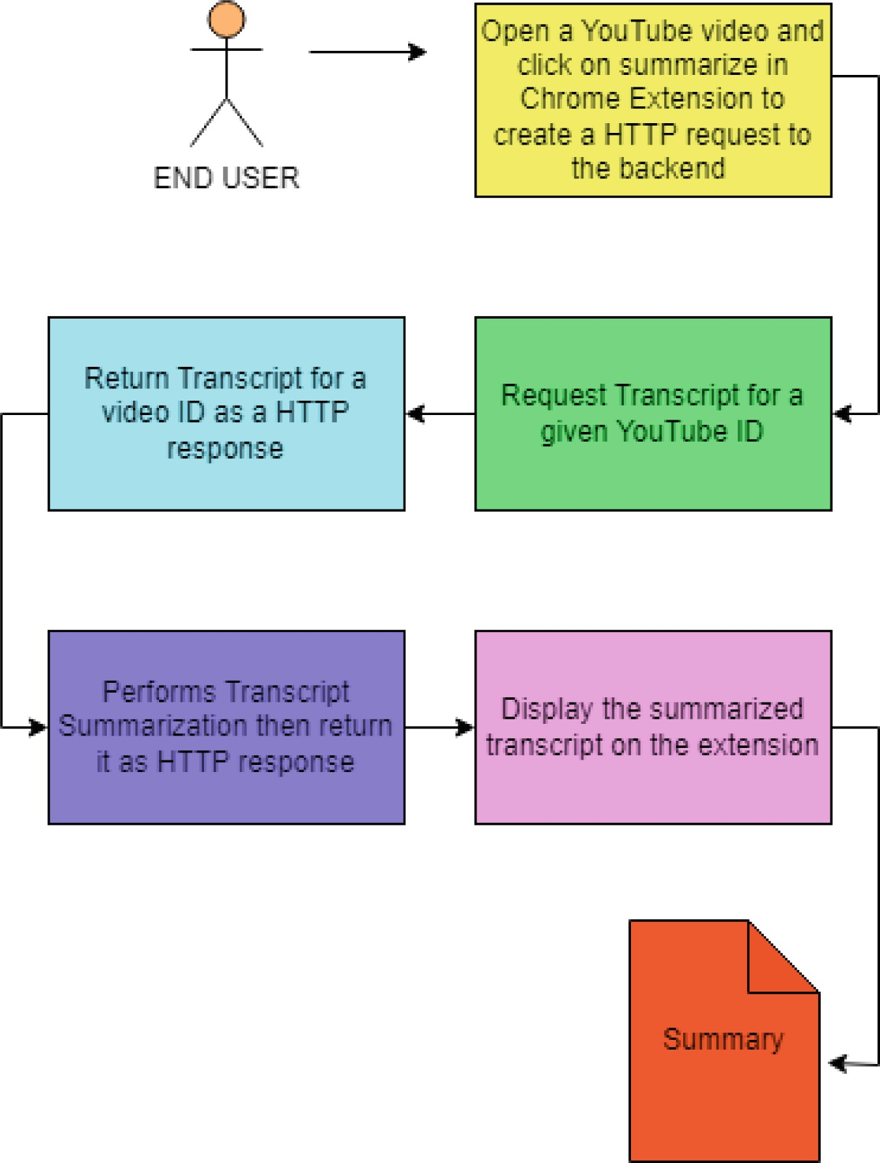

# CHAPTER 5: PROPOSED SYSTEM

The proposed system aims to automatically generate concise summaries for YouTube video tran- scripts using the T5 (Text-to-Text Transfer Transformer) model, a state-of-the-art natural language processing architecture developed by Google AI.

1. Data Collection and Preprocessing:

-Gather a diverse dataset of YouTube video transcripts paired with corresponding summary texts.

-Preprocess the data by cleaning, tokenizing, and formatting the text to ensure compatibility with the T5 model.

1. Model Architecture:

-Utilize the T5 model, which is a transformer-based architecture capable of handling various text generation tasks, including summarization.

-Fine-tune the pre-trained T5 model on the collected YouTube transcript-summary pairs using a sequence-to-sequence learning approach.

1. Training Process:

-Divide the dataset into training, validation, and testing sets.

-Implement fine-tuning by feeding the transcript-summary pairs into the T5 model and adjusting its parameters to minimize a loss function, such as cross-entropy loss, between generated and target summaries.

-Utilize techniques like beam search or nucleus sampling during inference to improve the quality of generated summaries.

1. Evaluation Metrics:

-Measure the performance of the trained model using standard evaluation metrics such as ROUGE (Recall-Oriented Understudy for Gisting Evaluation), BLEU (Bilingual Evaluation Understudy), and METEOR (Metric for Evaluation of Translation with Explicit Ordering).

-Additionally, conduct human evaluations to assess the readability, coherence, and relevance of the generated summaries compared to ground truth summaries.

1. Backend Implementation:

-Retrieve the transcript of the video corresponding to the provided URL.

-Integrate the T5 model for transcript summarization into the backend. Pass the retrieved tran- script through the T5 model to generate the summary.

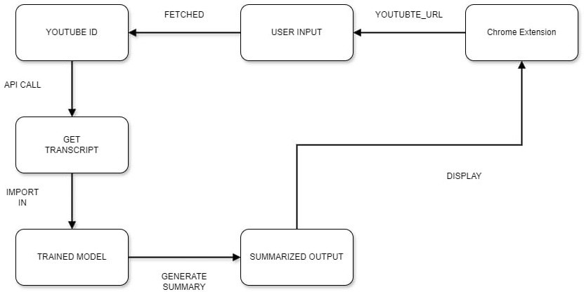

Figure 1: propoesd system

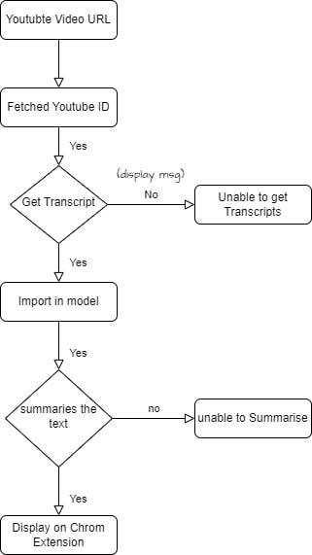

# CHAPTER 6: HARDWARE & SOFTWARE REQUIREMENT

### HARDWARE REQUIREMENTS :

1. Processor:

* Recommended: Intel Core i5 or higher
* Minimum: Intel Core i3 or equivalent

1. Speed:

* Recommended: 2.0 GHz or higher
* Minimum: 1.5 GHz

1. RAM:

* Recommended: 4 GB or higher
* Minimum: 2 GB

1. Hard Disk:

* Recommended: SSD with at least 128 GB storage
* Minimum: HDD with 80 GB storage

1. Input Devices:

* Standard keyboard compatible with the system
* Multi-button mouse for navigation and interaction

1. Monitor:

-Recommended: Full HD monitor (1920x1080 resolution)

* Minimum: SVGA monitor

### SOFTWARE REQUIREMENTS :

1. Operating System:

* Windows 10 (64-bit) or the latest version of macOS or a Linux distribution compatible with Python development

1. Python Development Environment:

* Python 3.x (latest version) installed

1. Integrated Development Environment (IDE):

* Recommended: PyCharm, Jupyter Notebook, or Visual Studio Code for Python coding and development

1. Additional Tools and Services:

* Optional access to cloud services or APIs for advanced AI capabilities or external integrations

# CHAPTER 7: APPLICATIONS

YouTube transcript summarizers can be incredibly useful tools for a variety of applications. Here are some potential uses:

1. Content Creation: Content creators can use YouTube transcript summarizers to quickly generate summaries of their own videos. This can be helpful for providing viewers with a brief overview of the video’s content before they watch it, or for repurposing the summary for other platforms like social media or blogs.
2. Viewer Engagement: Summarizing the transcripts of longer videos can help engage viewers who may not have the time or inclination to watch the entire video. By providing a concise sum- mary, creators can capture the essence of their content and cater to different audience preferences. 3.SEO Optimization: Summarized transcripts can be valuable for search engine optimization (SEO). By including relevant keywords and phrases in the summary, creators can improve the discoverability of their videos and attract more traffic to their channels.
3. Accessibility: Summarized transcripts can make video content more accessible to individuals with disabilities, such as those who are deaf or hard of hearing. By providing a textual summary of the audio content, creators can ensure that their videos are inclusive and reach a broader audi- ence.
4. Educational Purposes: YouTube transcript summarizers can be used in educational settings to create study guides or supplementary materials for students. Teachers can use summarized transcripts to highlight key concepts covered in educational videos and facilitate discussions or assignments based on the content.

### CHAPTER 8: IMPLEMENTATICHROME EXTENSION

# ON

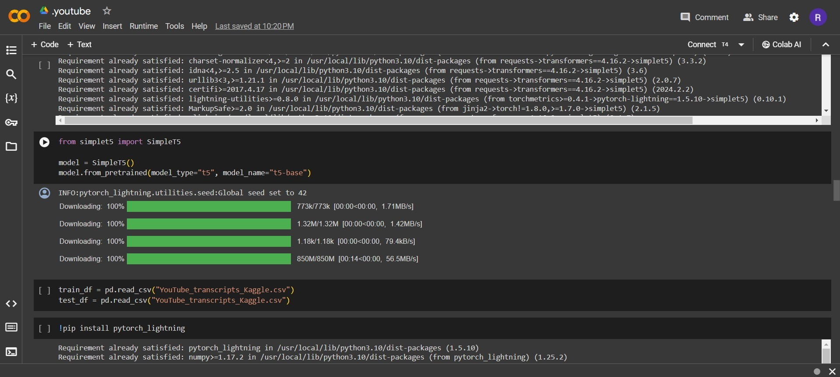

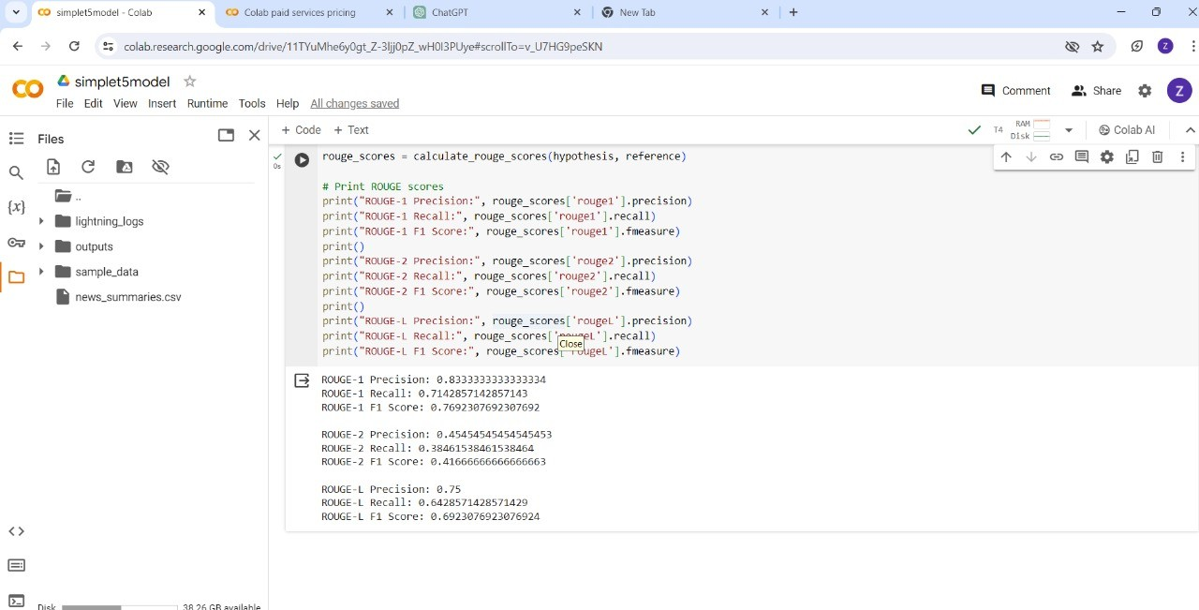

Figure 3: Model validation

Phas

# CHAPTER 9: FUTURE SCOPE

The field of YouTube transcript summarization is still evolving, and there is a lot of potential for future research and development. Some possible future scope for YouTube transcript summa- rizers are :

1. Multi-lingual support: As YouTube is a global platform with content in various languages, there is a need for transcript summarizers to support multiple languages. Future research can focus on developing transcript summarizers that can summarize transcripts in different languages.
2. Real-time summarization: Real-time summarization can be useful for live events or news broad- casts. Future research can focus on developing summarizers that can summarize the transcript in real-time.
3. Incorporating user feedback: User feedback can be used to improve the quality of the summary generated by the transcript summarizer. Future research can focus on developing summarizers that can incorporate user feedback to improve the accuracy and relevance of the summary.
4. Image and video analysis: The use of image and video analysis techniques can improve the accuracy and relevance of the summary generated by the transcript summarizer. Future research can focus on developing summarizers that can analyze images and videos to generate more infor- mative summaries.
5. Summarization based on user preferences: Different users may have different preferences for the type of summary they want. Future research can focus on developing summarizers that can generate personalized summaries based on the user’s preferences.
6. Evaluation metrics: There is a need for better evaluation metrics to measure the quality of the summaries generated by the transcript summarizer. Future research can focus on developing new evaluation metrics that can provide more insights into the quality of the summary

# CHAPTER 10: CONCLUSION

In conclusion, the integration of abstractive approaches in YouTube transcript summarization rep- resents a significant leap forward in content comprehension. By going beyond mere extraction, these approaches generate summaries infused with context and meaning, offering users a more nuanced understanding of video content. The presence of features like abstractive summaries, timestamp integration, and language converter enhances the user experience, making it both effi- cient and tailored to individual preferences.

Looking ahead, the future scope of YouTube transcript summarization holds promising av- enues. One such prospect involves the conversion of summaries into multiple languages, breaking down language barriers and expanding the global reach of video content. As technology contin- ues to advance, we can anticipate further refinements in abstractive summarization techniques, resulting in even more accurate and contextually rich summaries. In essence, YouTube transcript summarization, fueled by abstractive approaches and innovative features, is poised to redefine the way users engage with and comprehend video content, promising a more inclusive and globally accessible platform.

# CHAPTER 11: REFERENCES

1. Survey on Abstractive Transcript Summarization of Youtube videos by S. Tharun, R. Kranthi Kumar, P. Sai Sravanth, G. Srujan Reddy, and B. Akshay

https://ijarsct.co.in/Paper391.pdf

1. Youtube Transcript summarizer by Krutika Bobade, Aditi Charlawar, Pratiksha Fusate, Awani Karkade, Manoj Chittawar from Department of Computer Science Engineering, Rajiv Gandhi College of Engineering Research and Technology, Chandrapur, Maharashtra, India https://ijcrt.org/papers/IJCRT2312095.pdf
2. YouTube Transcript summarizer by Siddhartha, Parshu Pandey, Ansh Saxena from SCSE Galgotias University, Gautam Budh nagar, Greater Noida

[https://www.ijres.org/papers/](http://www.ijres.org/papers/Volume-11/Issue-5/1105189195.pdf)V[olume-11/Issue-5/1105189195.pdf](http://www.ijres.org/papers/Volume-11/Issue-5/1105189195.pdf)

1. Abstractive summarizer for Youtube videos by Sulochana Devi, Rahul Nadar, Tejas Nichat and Alfredprem Lucas from Department of Information Technology, Xavier Institute of Engi- neering, Mumbai [https://www.researchgate.net/publication/370422731](http://www.researchgate.net/publication/370422731AbstractiveS)*Abstr*[*activ*](http://www.researchgate.net/publication/370422731AbstractiveS)*eSummarizerf orY ouTubeV ideos*